**Weather Prediction**

**What is weather prediction?**

Weather prediction, often known as weather forecasting, is the act of predicting the state of the atmosphere at a specific time and location in the future. It is a critical field of research for comprehending and forecasting the behaviour of our planet's atmosphere, which is constantly changing owing to natural and man-made forces. Accurate weather prediction has several uses, including agriculture, transportation, aviation, and disaster management.

Because of their capacity to model complex connections and patterns in huge datasets, machine learning approaches have grown in popularity in weather prediction. With huge volumes of weather data available from multiple sources such as satellites, radars, and weather stations, machine learning systems may learn from this data to effectively anticipate weather conditions.

In this project, we will look at the many data sources utilised in weather forecasting, as well as the various machine learning methods used for weather prediction and their benefits and drawbacks. Finally, we will compare the performance of a machine learning model trained on weather data.

**Dataset**

The dataset used for this project contains the weather conditions of Seattle. It is a frequently used dataset used in the process of Weather Prediction. The dataset contains 1461 rows and 6 attributes. A brief description of the attributes:

**Date**

**Precipitation:** Indicates all forms in which the water falls on earth as rain, hail etc.

**temp_max :** Indicates the maximum temperature

**temp_min :** Indicates the minimum temperature

**wind :** Indicates the wind speed

**weather :** Indicates the type of the weather ( drizzle, rain, sun, snow, fog)

Link to download the dataset: [Link](https://www.kaggle.com/datasets/ananthr1/weather-prediction)

**Tools and Libraries Used**

The project makes use of the following Python libraries:

· NumPy

· Pandas

· Matplotlib

· Seaborn

· Scikit-Learn

· Plotly

**Steps for Weather Prediction using Machine Learning**

1. In the first step, the necessary machine learning libraries will be imported.

| import pandas as pd import numpy as np import seaborn as sns import matplotlib.pyplot as plt import plotly.express as px |
| --- |

2. In the next step, the dataset is read using the **read_csv()** function and the first 5 rows of the dataset can be displayed.

| #Load the dataset data = pd.read_csv("weather.csv") data.head() |
| --- |

Output

The output image displays the first 5 rows of the dataset.

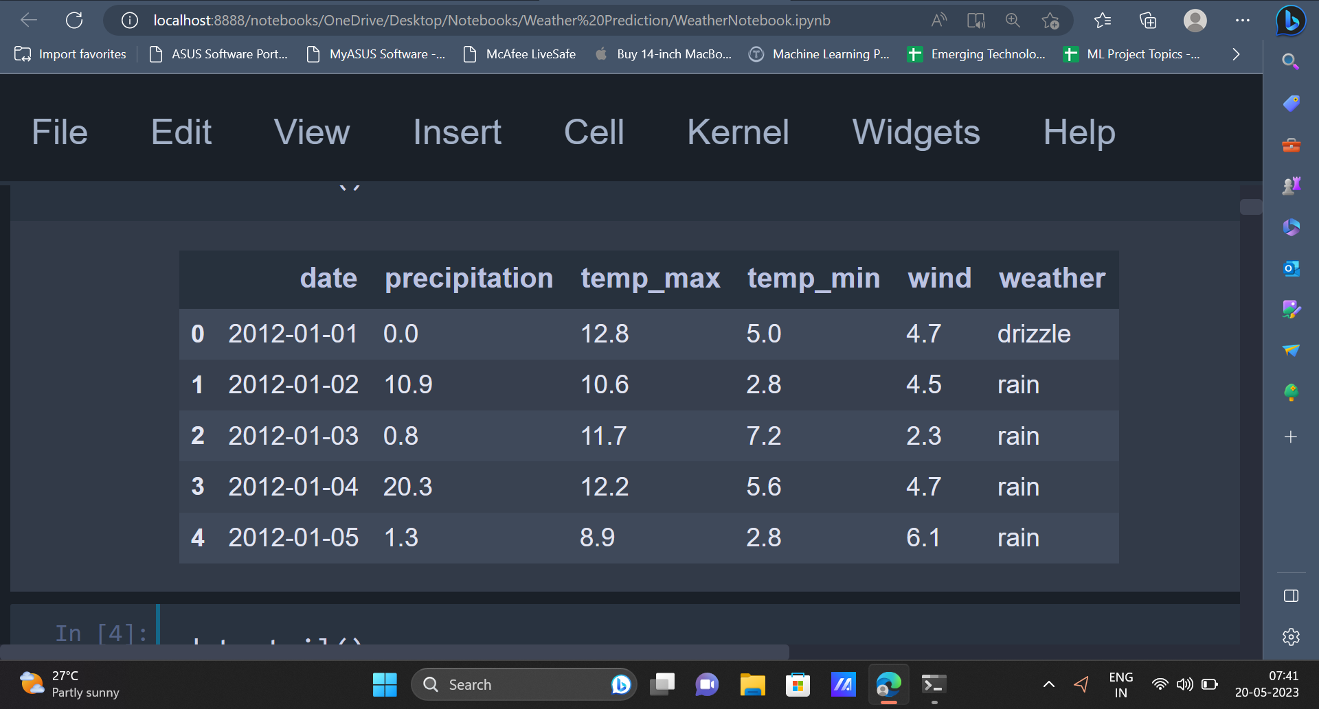

3. Once the dataset is read and displayed, various exploratory data analysis techniques can be implemented on the dataset to gain more insights about the dataset.

| data.info() |
| --- |

Output

The **info()** function is used to display the number of rows and columns present in the dataset, the number of non null values and the data type of all the attributes present in the dataset. The dataset contains 1461 rows, 6 columns.

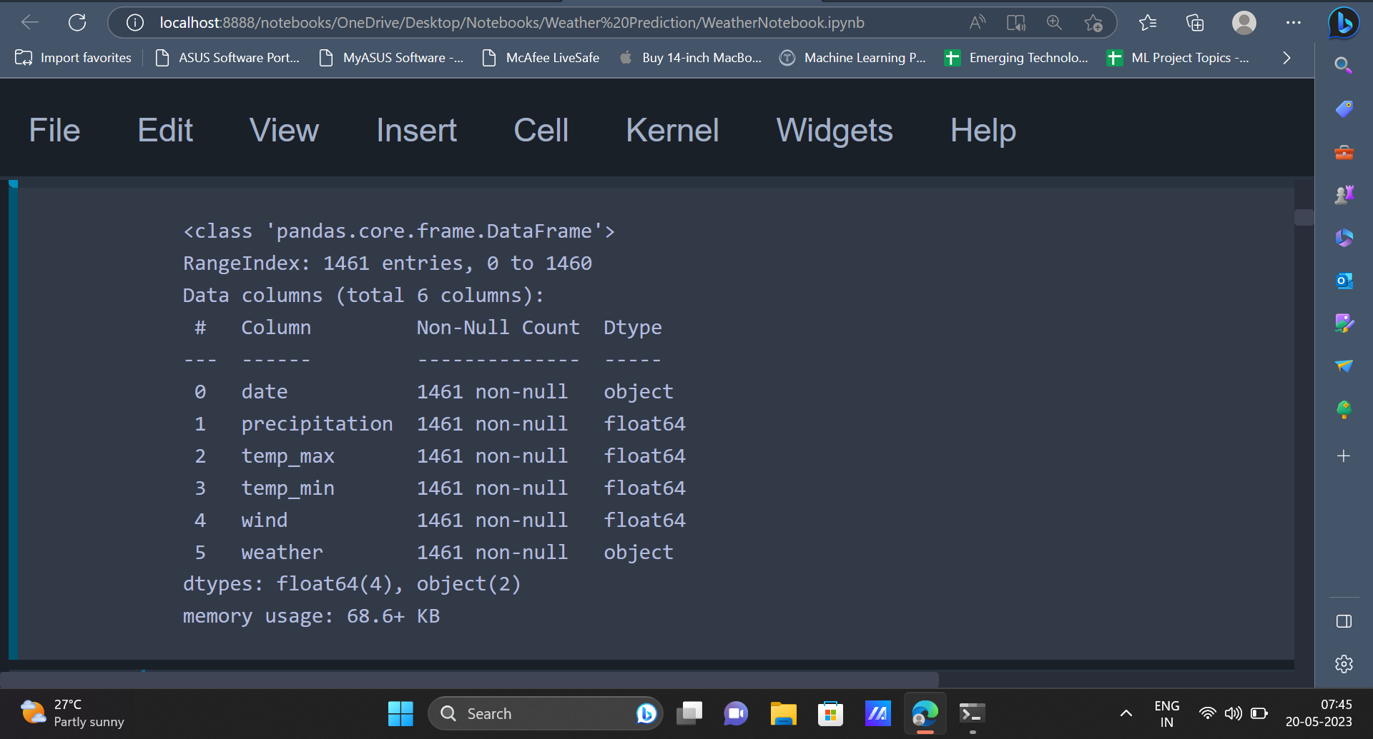

4. Another way to check if there are any null values present in the dataset is to use the

**isnull()** function. The **sum()** function can be used along with the isnull() function to get the sum of null values in all the attributes.

| #Check for null values data.isnull().sum() |
| --- |

Output

The output contains 0 as value for all the columns. This means that there are no null values in any of the columns.

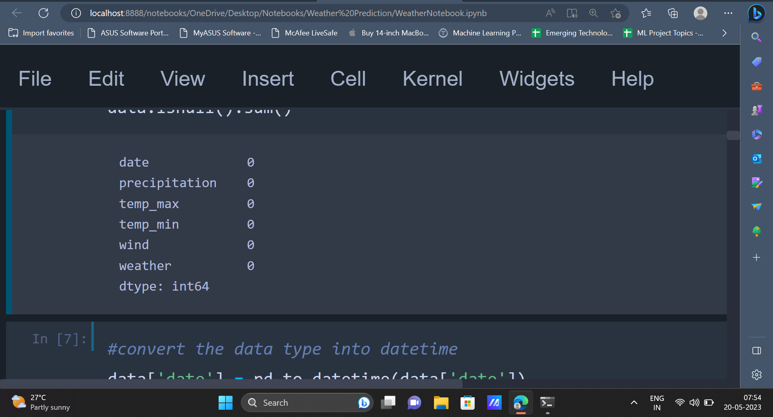

5. In the next step, the values present in the **date** column will be converted into date time format using the Pandas **to_datetime()** function.

| #convert the data type into datetime data['date'] = pd.to_datetime(data['date']) |
| --- |

6. After exploring the dataset, data visualisation techniques can be implemented to represent the data using graphs and charts.

| plt.figure(figsize=(10,5)) sns.set_theme() sns.countplot(x = 'weather',data = data,palette="ch:start=.2,rot=-.3") plt.xlabel("weather",fontweight='bold',size=13) plt.ylabel("Count",fontweight='bold',size=13) plt.show() |
| --- |

Output

The output displays the values present in the **weather** column using a countplot. It can be seen that the values **rain** and **sun** have the highest number of occurrences and the value **snow** has the least occurrence.

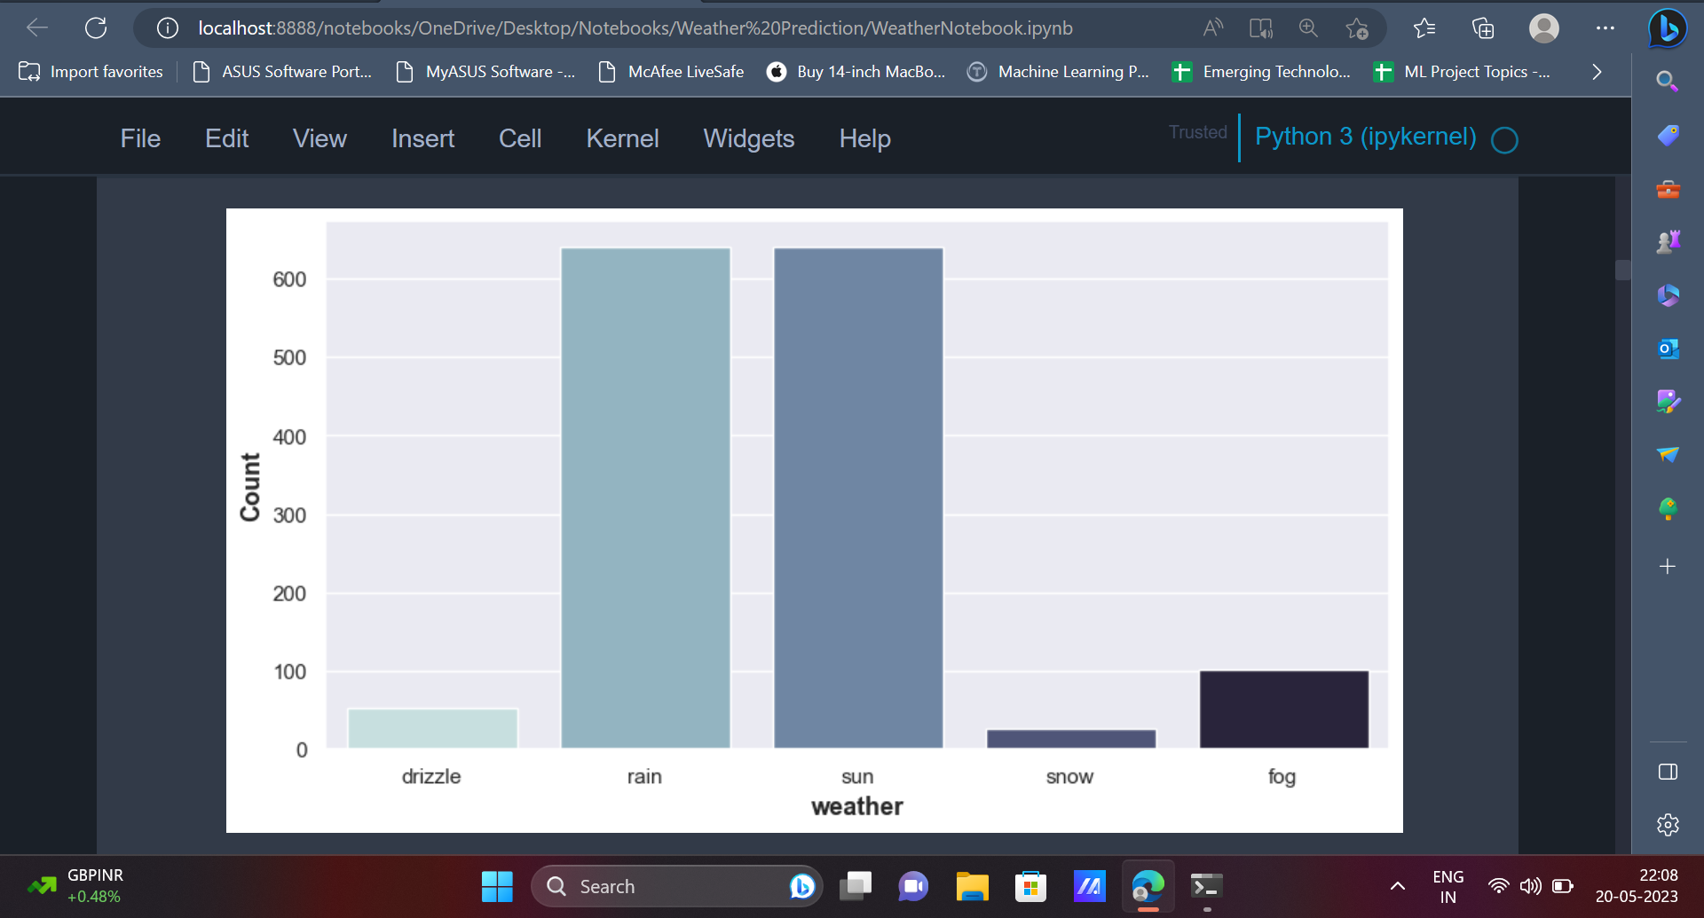

The line chart can be used to display the variation of **maximum temperature** on different dates.

| px.line(data_frame = data,  x = 'date',  y = 'temp_max',   title = 'Variation of Maximum Temperature') |
| --- |

Output

Since the graph is made using **Plotly**, the graph can be zoomed in and zoomed out to find out more details or to gain more insights. The same line chart can be implemented for values present in other columns as well.

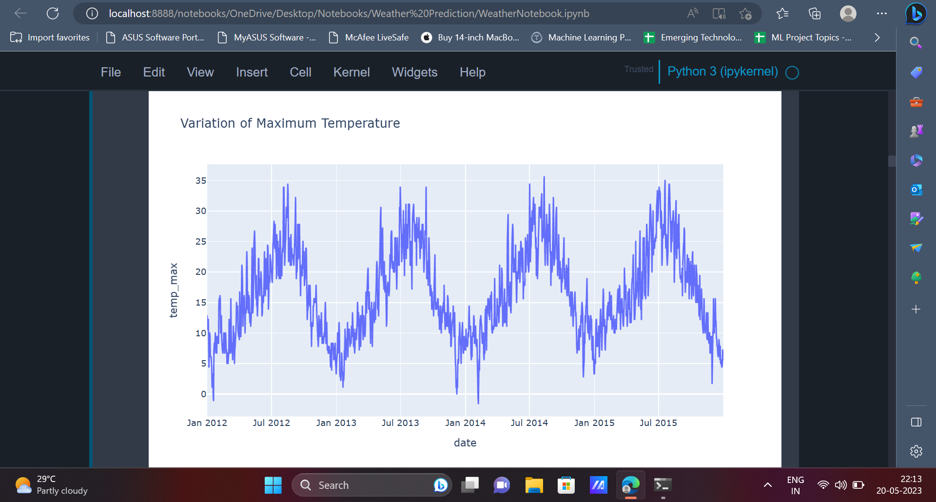

| px.line(data_frame = data,  x = 'date',  y = 'temp_min',   title = 'Variation of Minimum Temperature') |
| --- |

Output

Similar to the previous figure, the below output displays the variation of **minimum temperature** on different dates.

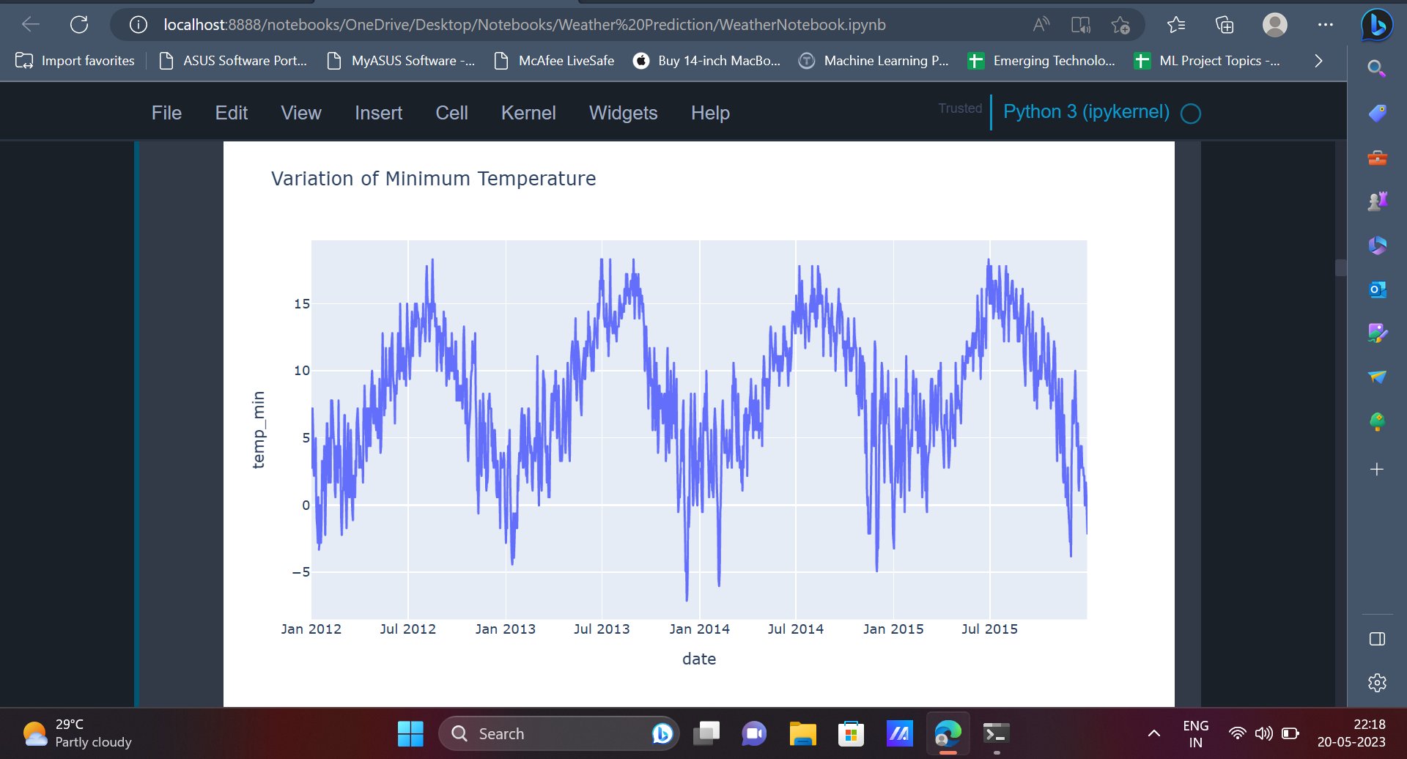

7. Catplot is a shorthand for categorical plot, which can be implemented to analyse the relationship between variables. The catplot provides the ability to create different categorical plots.

| plt.figure(figsize=(10,5)) sns.catplot(x='weather',y ='temp_max',data=data,palette="crest") plt.show() |
| --- |

Output

The output displays the relationship between the categorical variable(**weather**) and the numeric variable(**maximum temperature**). Each data point is represented by a scatter point, and the categorical factors decide how the scatter points are coloured and organised.

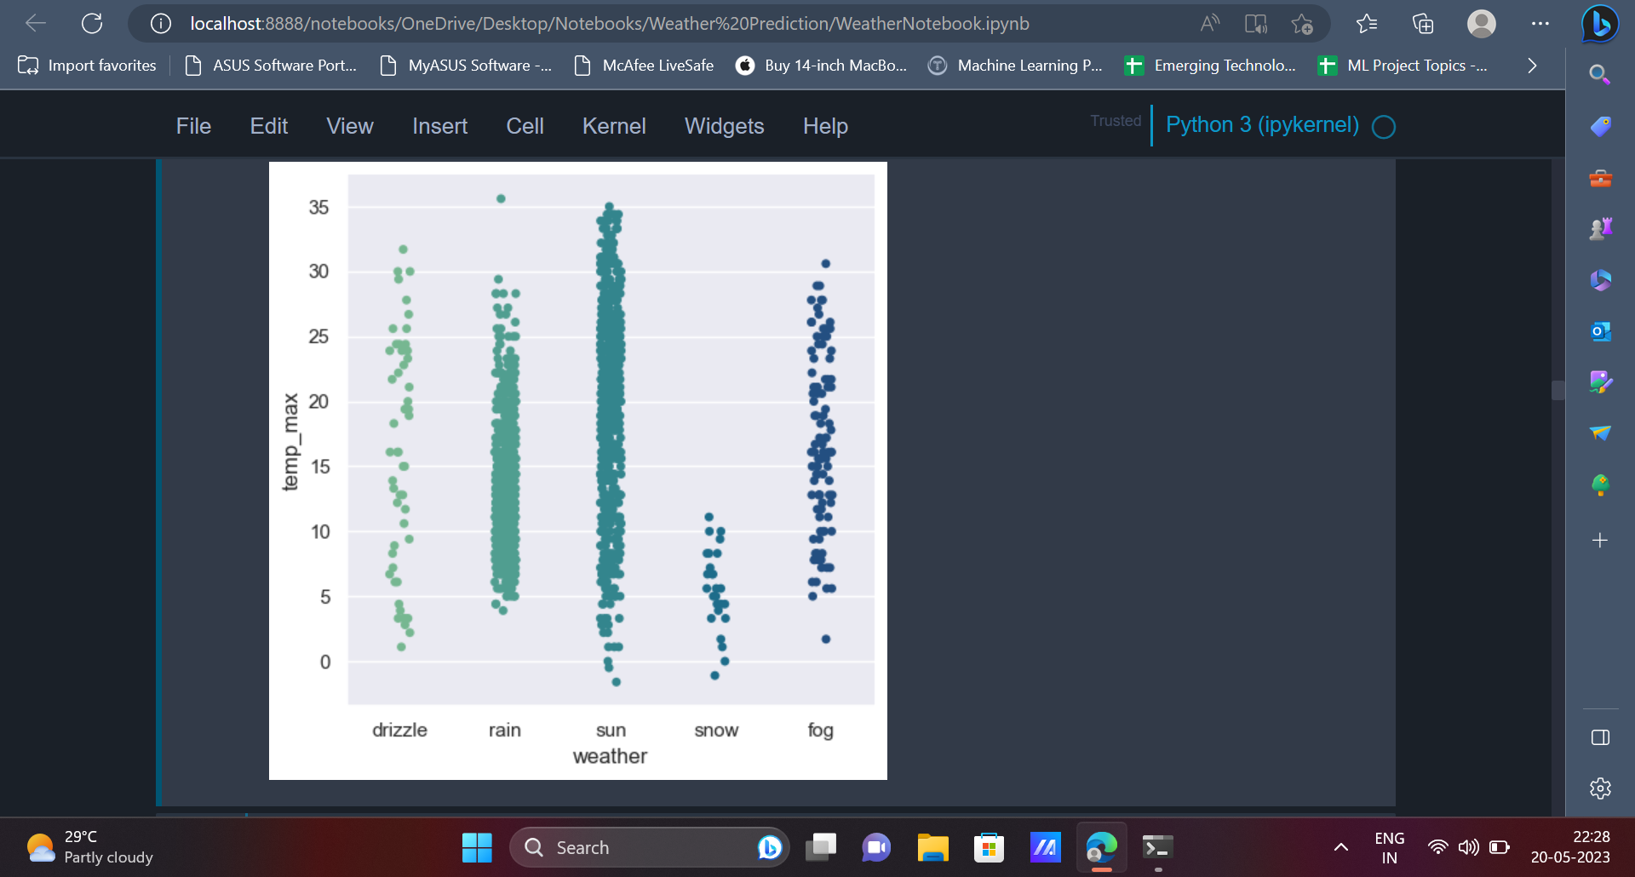

| plt.figure(figsize=(10,5)) sns.catplot(x='weather',y ='temp_min',data=data,palette = "RdBu") plt.show() |
| --- |

Output

The output contains the catplot for the **weather** column and the **temp_min** column.

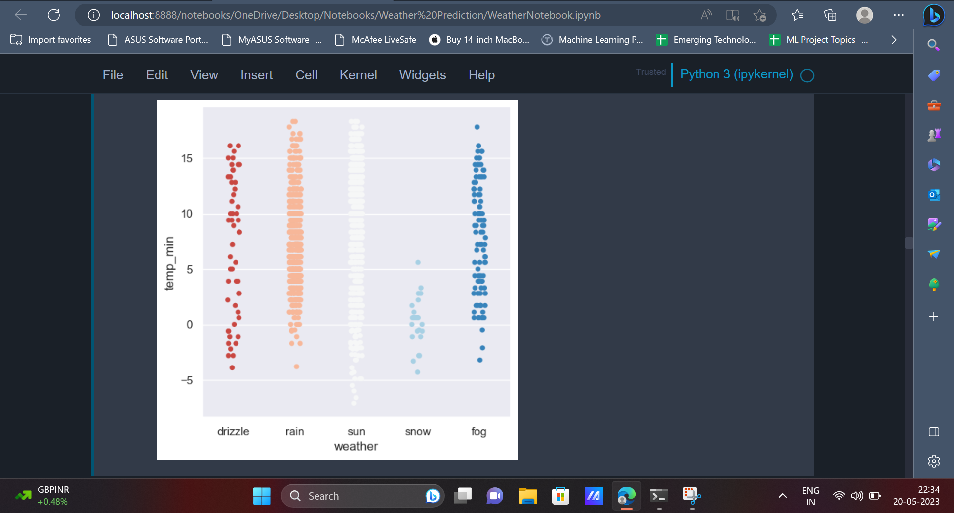

8. Following data visualisation, the data can be pre-processed to convert the data into a form which can be better understood by Machine Learning models. We define a function called LABEL_ENCODING which can be used to convert categorical values into numerical values where in each categorical value is assigned with a unique integer value. We use this concept to convert the values in the **weather** column into integer values.

| def LABEL_ENCODING(c1):  from sklearn import preprocessing  label_encoder = preprocessing.LabelEncoder()  data[c1]= label_encoder.fit_transform(data[c1])  data[c1].unique() LABEL_ENCODING("weather") |
| --- |

9. Since the **date** column does not have any significance in the weather prediction, this column can be removed from the dataframe.

| data = data.drop('date',axis=1) |
| --- |

10. After preprocessing the data, it can be split into independent variables(X) and dependent variables(y) using the below code.

| x = data.drop('weather',axis=1) y = data['weather'] |
| --- |

All attributes except **weather** are independent variables/ independent attributes while **weather** is a dependent attribute.

11. It is important to split the dataset into training data and testing data which can be later used to train the models and evaluate various models performance respectively.

| from sklearn.model_selection import train_test_split X_train, X_test, y_train, y_test = train_test_split(x, y, test_size = 0.25, random_state = 0) |
| --- |

75% of the data is considered as training data and 25% of the data is considered as testing data/test data.

12. Before we go ahead and start training Machine Learning models using the training data, we will make use of StandardScalerwhich is an in-built sklearn preprocessing technique. It is a common method used in machine learning to normalise numerical data before feeding it into models that require standardisation.

| from sklearn.preprocessing import StandardScaler sc = StandardScaler() X_train = sc.fit_transform(X_train) X_test = sc.transform(X_test) |
| --- |

13. The first model which will be trained on the dataset would be Logistic Regression.

| from sklearn.linear_model import LogisticRegression classifier = LogisticRegression(random_state = 0) classifier.fit(X_train, y_train) |
| --- |

Predictions from the Logistic Regression model can be made using the **predict()** function.

| y_pred = classifier.predict(X_test) |
| --- |

The performance of models can be evaluated using metrics like **confusion matrix**, **accuracy score** etc.

| sns.heatmap(cm,annot=True, fmt = '.3g') acc1 = accuracy_score(y_test, y_pred) print(f"Accuracy score: {acc1}") plt.show() |
| --- |

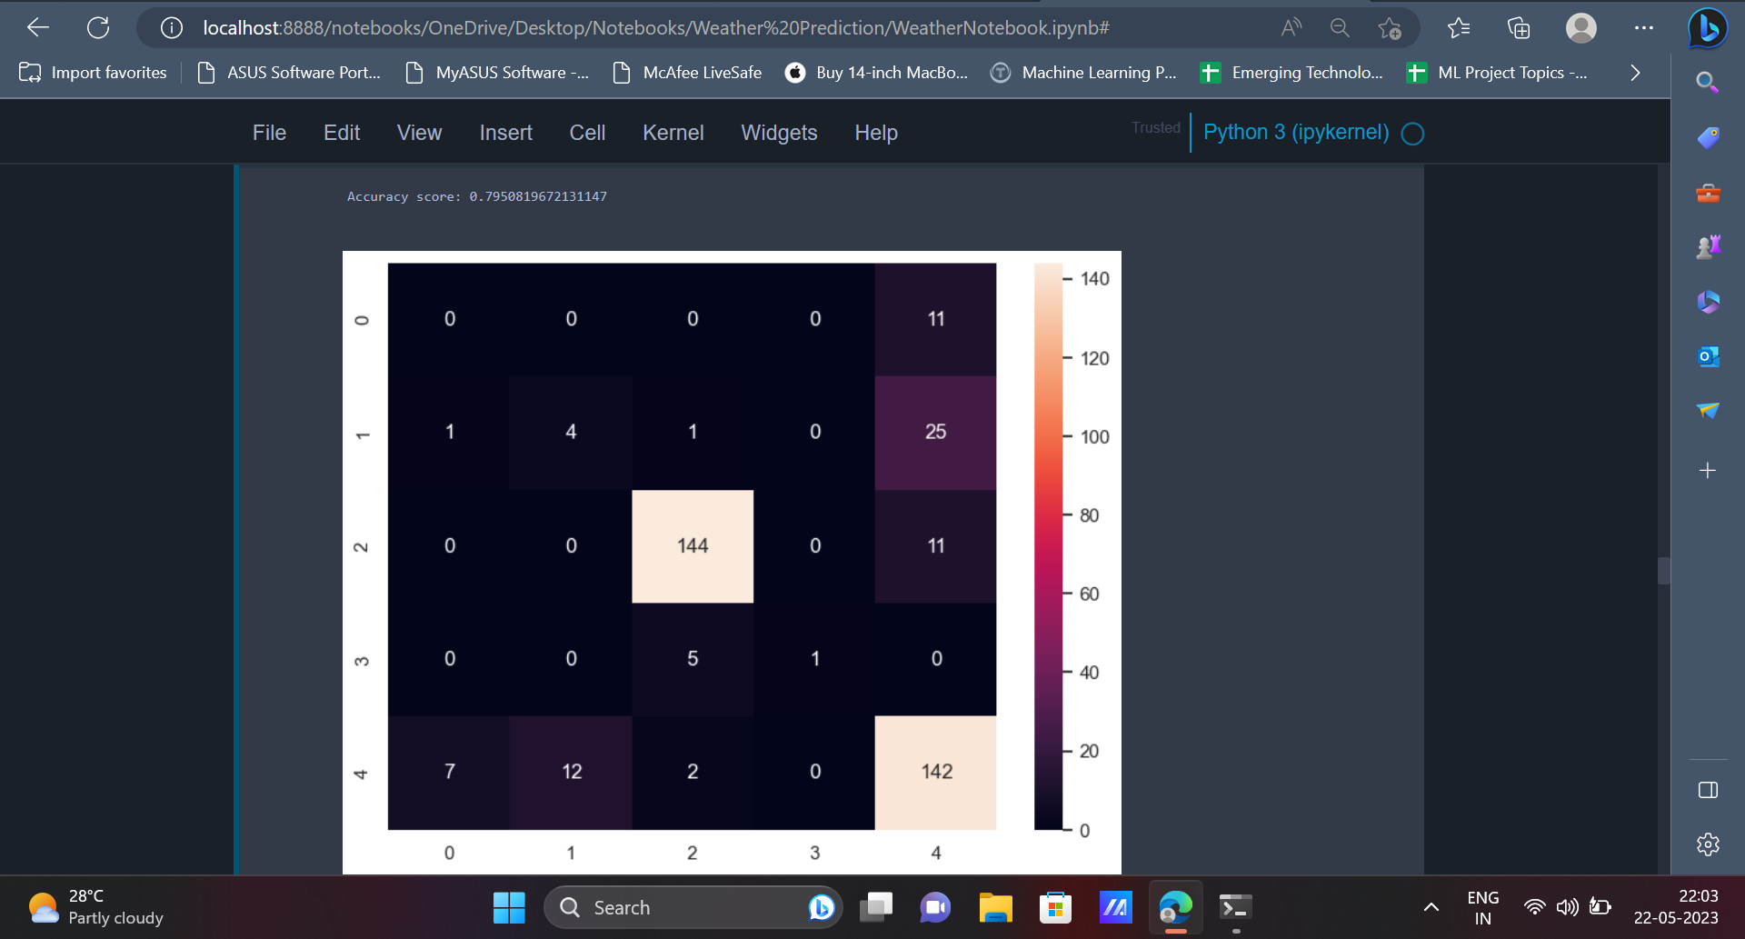

The values present in the diagonal of the confusion matrix (0,4,144,1,142) represent the number of data points which have been correctly classified by the model. From the accuracy score, it is evident that the model has an accuracy of **79.5%**.

14. The next algorithm which will be used is the Naive Bayes Classifier.

| from sklearn.naive_bayes import GaussianNB classifier = GaussianNB() classifier.fit(X_train, y_train) |
| --- |

The predictions are made in a way similar to how it was made earlier.

| y_pred = classifier.predict(X_test) |
| --- |

| cm = confusion_matrix(y_test, y_pred) sns.heatmap(cm, annot = True, fmt = '.3g') acc = accuracy_score(y_test, y_pred) print(f"Accuracy score : {acc}") |
| --- |

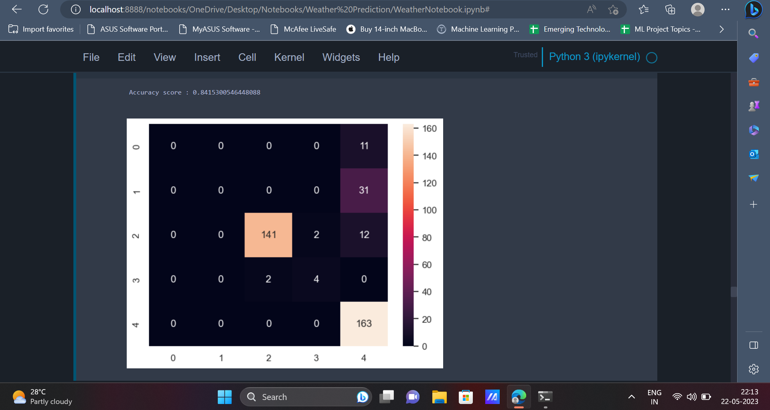

The Naive Bayes Classifier has an accuracy of **84.15**%.

15. The last model which will be trained on the dataset would be the Support Vector Classifier.

| from sklearn.svm import SVC classifier = SVC(kernel = 'linear', random_state = 0) classifier.fit(X_train, y_train)  y_pred = classifier.predict(X_test) |
| --- |

The confusion matrix and accuracy score can be displayed like earlier.

| cm = confusion_matrix(y_test, y_pred) sns.heatmap(cm, annot = True, fmt = '0.3g') print(accuracy_score(y_test, y_pred)) |
| --- |

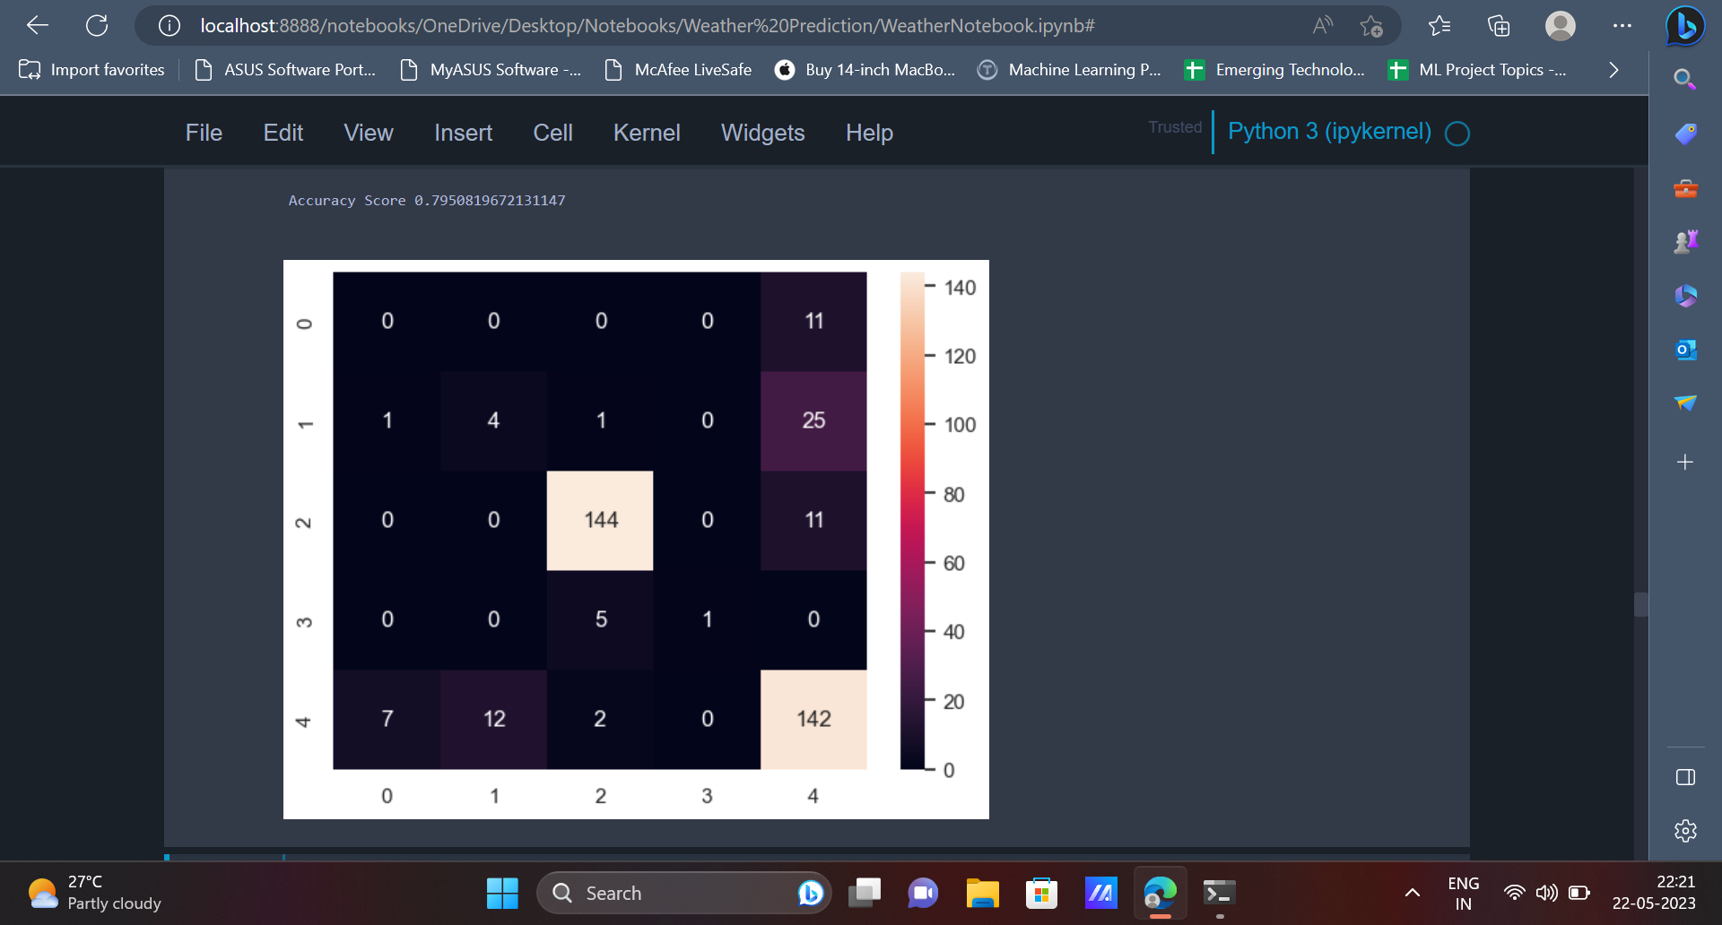

The Support Vector Classifier provides an accuracy of **79.5** % on the dataset.

**Conclusion**

In conclusion, the project demonstrates the potential of machine learning in improving weather forecasting, aiding in decision-making processes, and assisting in various sectors such as agriculture, transportation, and emergency preparedness. While further research and improvements are necessary, this project highlights the significant potential of machine learning in enhancing weather prediction capabilities and advancing our understanding of atmospheric phenomena.

**Comments**

* Write a brief paragraph about prerequisites of the project.